|  |
| --- |
| **LAPORAN PRAKTIKUM JARINGAN KOMPUTER**  **4.7.1**  **PACKET TRACER – CONNECT THE PHYSICAL LAYER** |
|  |
| **Agus Pranata Marpaung**  **13323033**  **DIII TEKNOLOGI KOMPUTER** |
| **INSTITUT TEKNOLOGI DEL**  **FAKULTAS VOKASI** |

**Judul Praktikum**

|  |  |  |
| --- | --- | --- |
| **Minggu/Sesi** | : | II/3 |
| **Kode Mata Kuliah** | : | 1032101 |
| **Nama Mata Kuliah** | : | JARINGAN KOMPUTER |
| **Setoran** | : | Jawaban dalam bentuk *softcopy* |
| **Batas Waktu Setoran** | : | *Sesi Praktikum Selanjutnya* |
| **Tujuan** | : | 1. Mahasiswa dapat mengerti cara kerja TCP/IP dan relasinya dengan OSI model. serta dapat menentukan jenis kabel yang tepat untuk menghubungkan perangkat jaringan. |

**Petunjuk**



**Packet Tracer - Connect the Physical Layer**

**Objectives**

**Part 1: Identify Physical Characteristics of Internetworking Devices**

**Part 2: Select Correct Modules for Connectivity**

**Part 3: Connect Devices**

**Part 4: Check Connectivity**

**Background**

In this activity, you will explore the different options available on internetworking devices. You will also be required to determine which options provide the necessary connectivity when connecting multiple devices. Finally, you will add the correct modules and connect the devices.

**Note**: Scoring for this activity is a combination of Packet Tracer-automated scoring and your recorded answers to the questions posed in the instructions. See the Error! Not a valid bookmark self-reference.at the end of this activity and consult with your instructor to determine your final score.

**Part 1: Identify Physical Characteristics of Internetworking Devices**

**Step 1: Identify the management ports of a Cisco router.**

1. Click the **East** router. The **Physical** tab should be active.

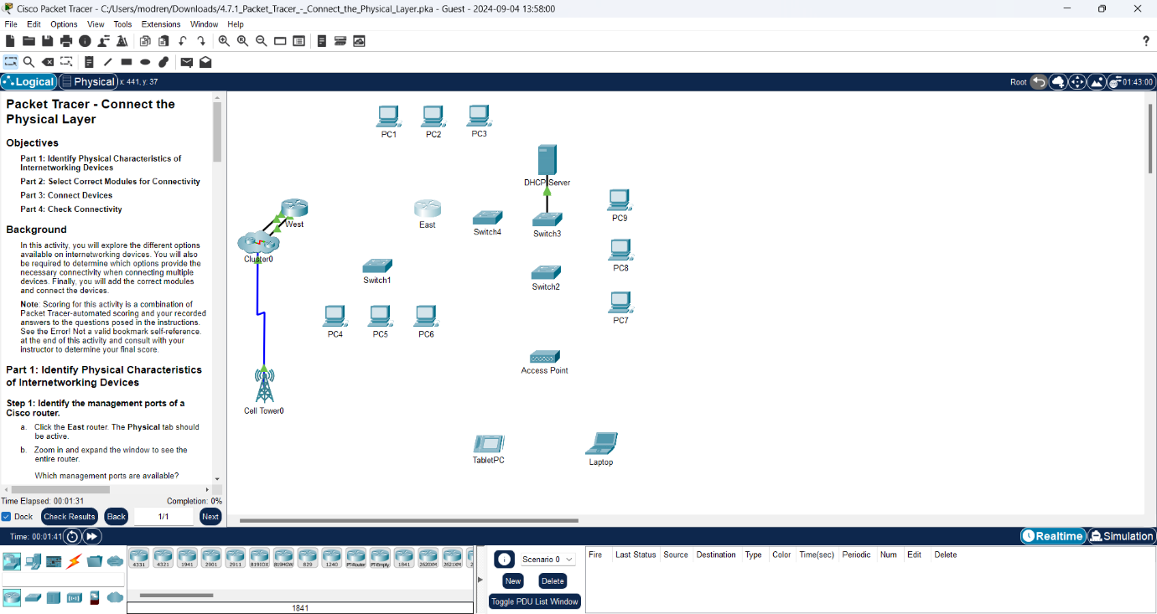

1. Zoom in and expand the window to see the entire router.

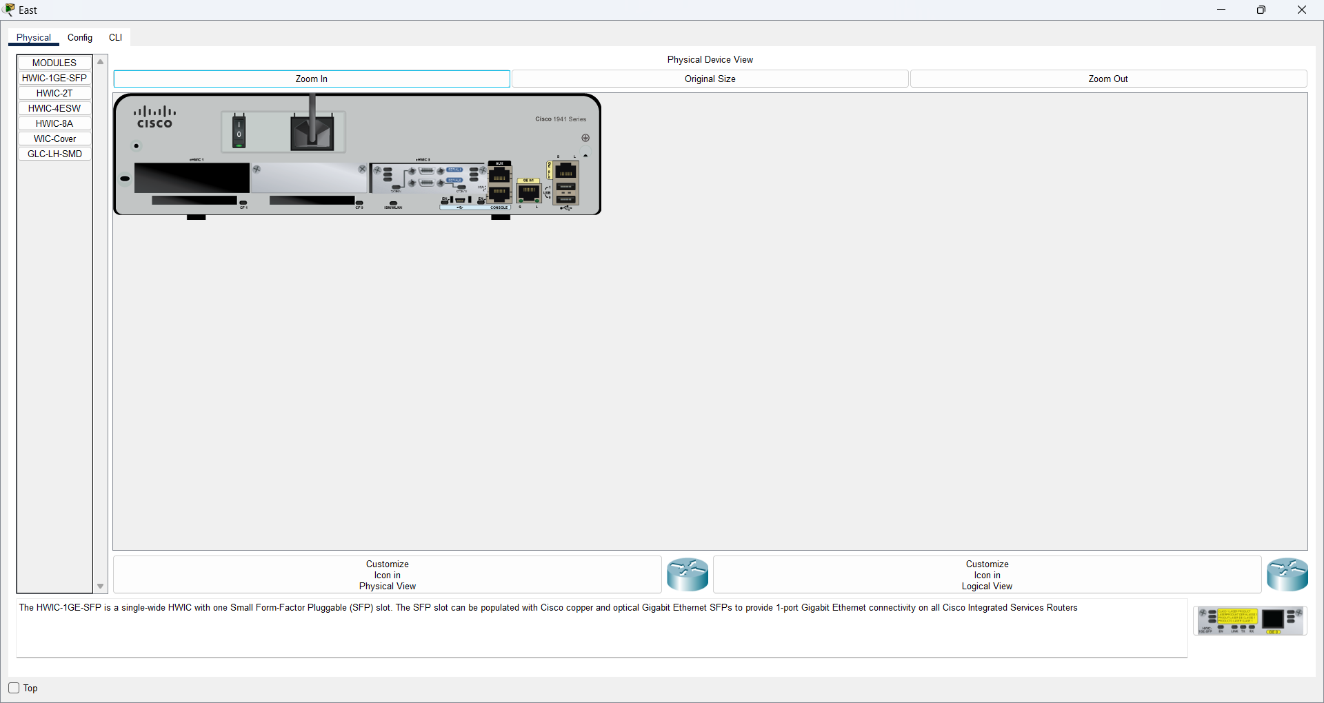

Which management ports are available?

**Answer:**

Available ports are AUX port and Console Ports.

**Step 2: Identify the LAN and WAN interfaces of a Cisco router.**

1. Which LAN and WAN interfaces are available on the **East** router and how many are there?

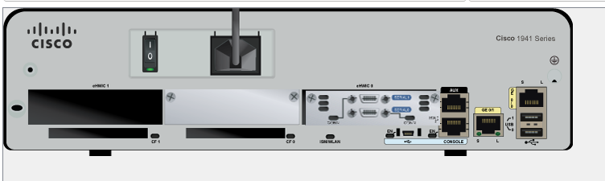

**Answer:**

The LAN consists of 2 Gigabit Ethernet and the WAN consists of 2 WAN Interfaces. **Red** is WAN Interface and **Blue** is LAN.

1. Click the **CLI** tab, press the **Enter** key to access the user mode prompt, and enter the following commands:

East> **show ip interface brief**

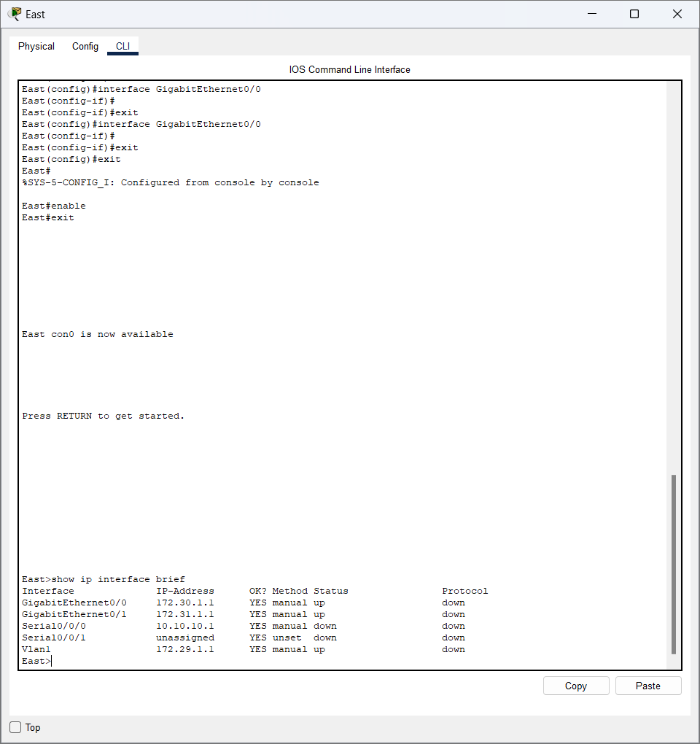

The output verifies the correct number of interfaces and their designation. The vlan1 interface is a virtual interface that only exists in software.

How many physical interfaces are listed?

**Answer:**

There are 4 physical interfaces, namely GigabitEthernet0/0, GigabitEthernet0/1, Serial0/0/0, and Serial0/0/1.

1. Enter the following commands:

East> **show interface gigabitethernet 0/0**

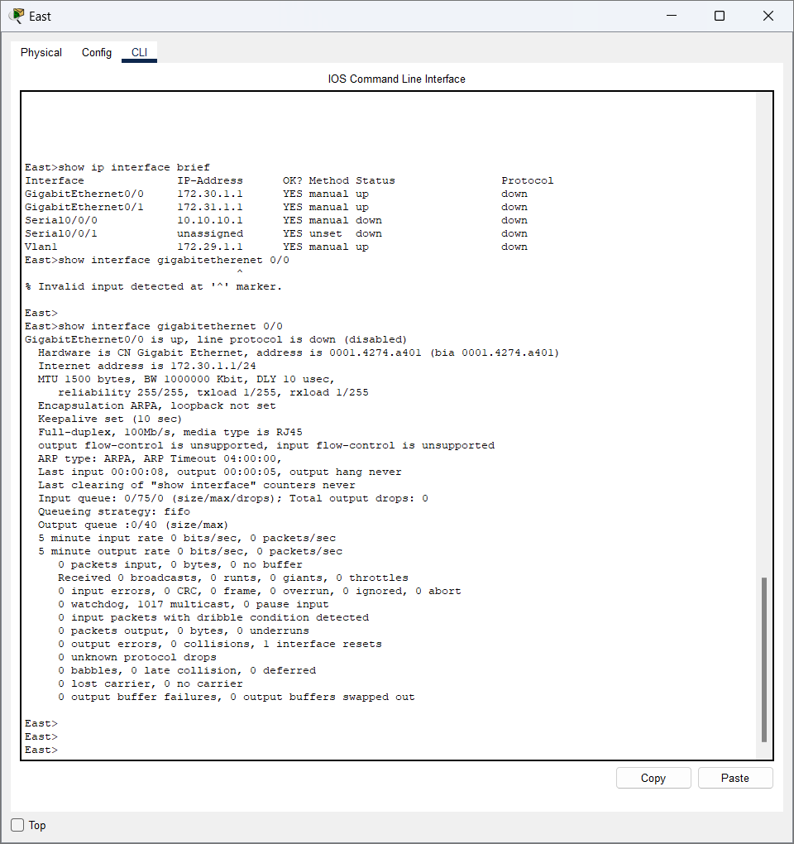

What is the default bandwidth of this interface?

**Answer:**

The default bandwith for GigabitEthernet 0/0 is 1000000 Kbit

East> **show interface serial 0/0/0**

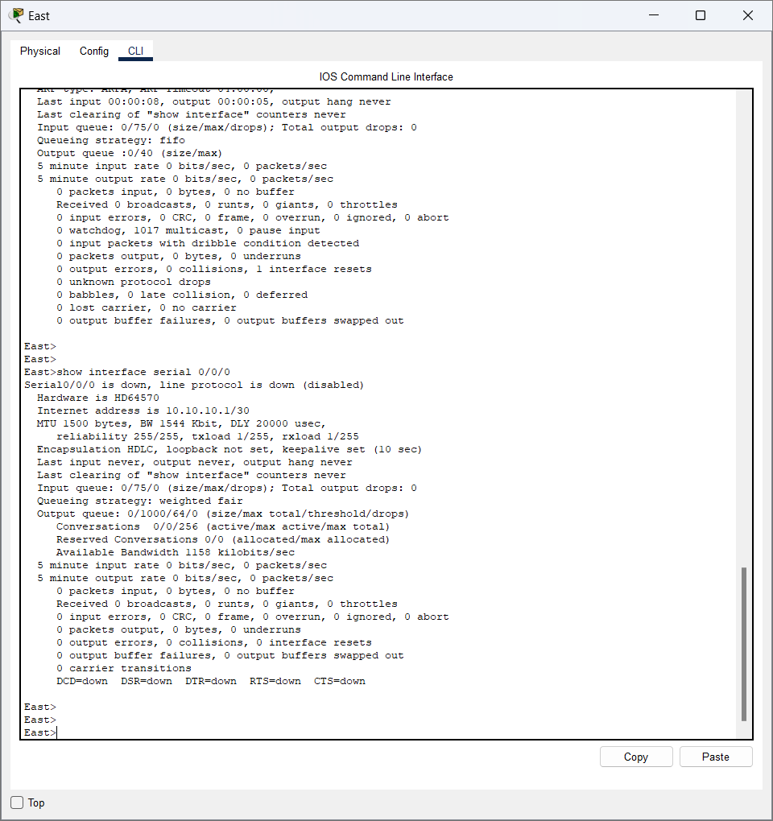

What is the default bandwidth of this interface?

**Answer:**

The default bandwidth for Serial 0/0/0 is 1544 Kbit

**Note:** Bandwidth on serial interfaces is used by routing processes to determine the best path to a destination. It does not indicate the actual bandwidth of the interface. Actual bandwidth is negotiated with a service provider.

**Step 3: Identify module expansion slots.**

:

How many expansion slots are available to add additional modules to the **East** router?

**Answer:**



The additional slots available for adding modules to the East Router are 1 slot.

Click **Switch2**.How many expansion slots are available?

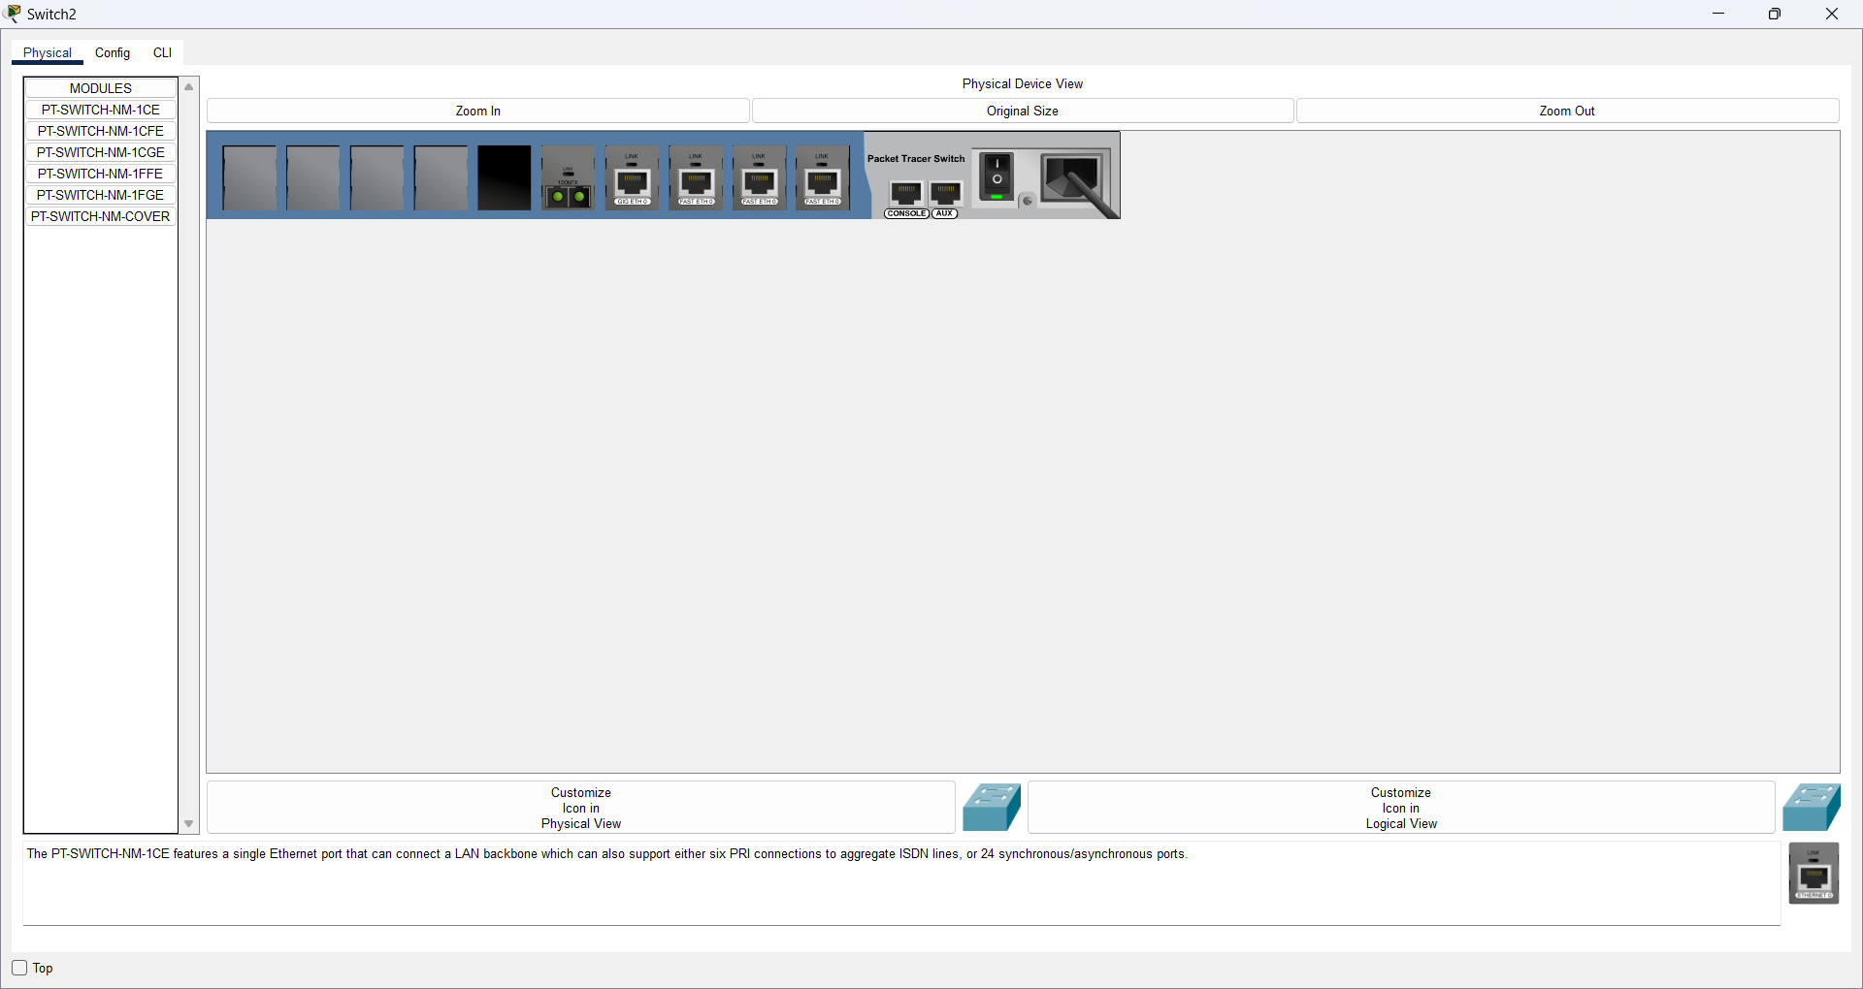

**Answer:**

The available slots on Switch 2 are 5 slots.

***pe your answers here.***

**Part 2: Select Correct Modules for Connectivity**

**Step 1: Determine which modules provide the required connectivity.**

1. Click **East** and then click the **Physical** tab. On the left, beneath the **Modules** label, you see the available options to expand the capabilities of the router. Click each module. A picture and a description display at the bottom. Familiarize yourself with these options.
2. You need to connect PCs 1, 2, and 3 to the **East** router, but you do not have the necessary funds to purchase a new switch. Which module can you use to connect the three PCs to the **East** router?

**Answer:**

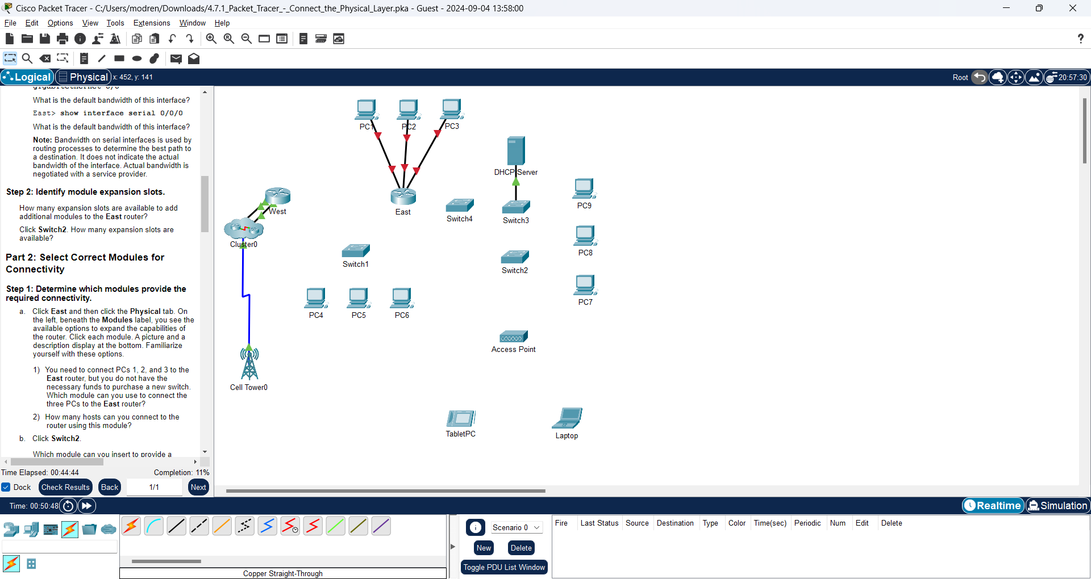

**East Router**

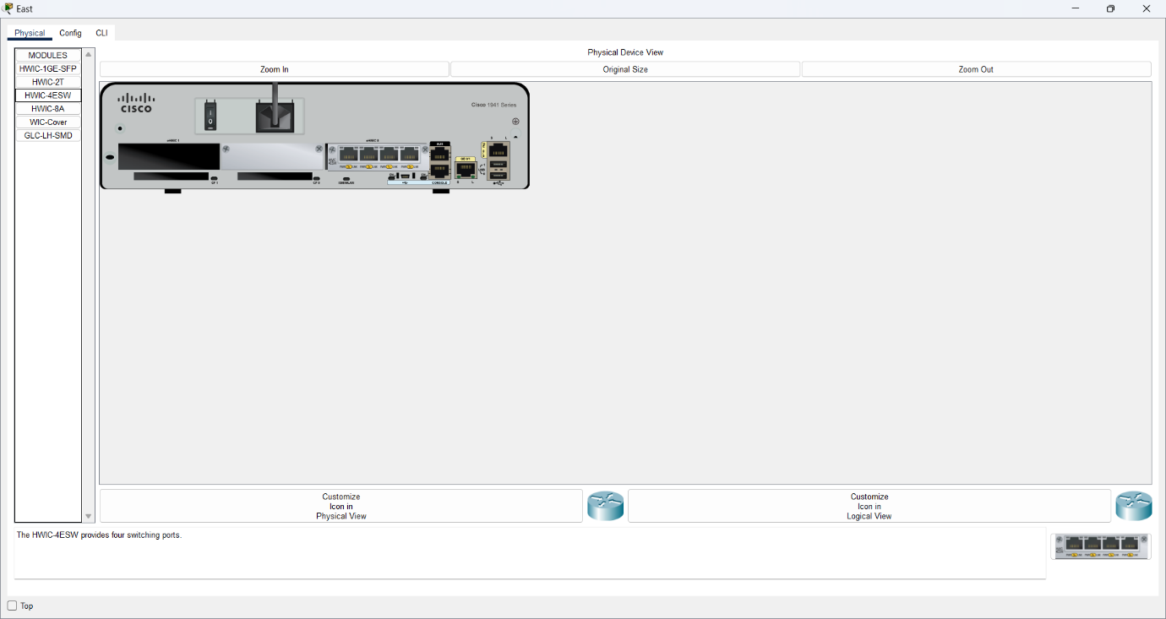

The module that I connected for the three PCs to the East Router is the HWIC-4ESW Module.

1. How many hosts can you connect to the router using this module?

**Answer:**

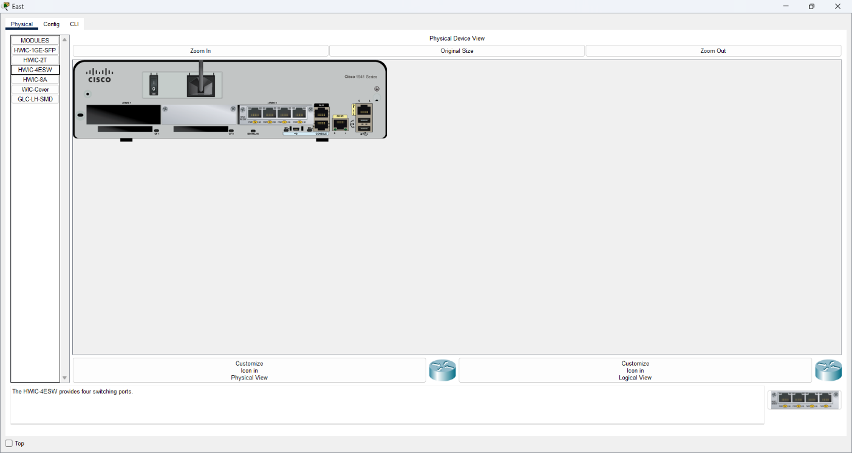

Hosts that can connect to the router using this module are 4 modules.

1. Click **Switch2**.

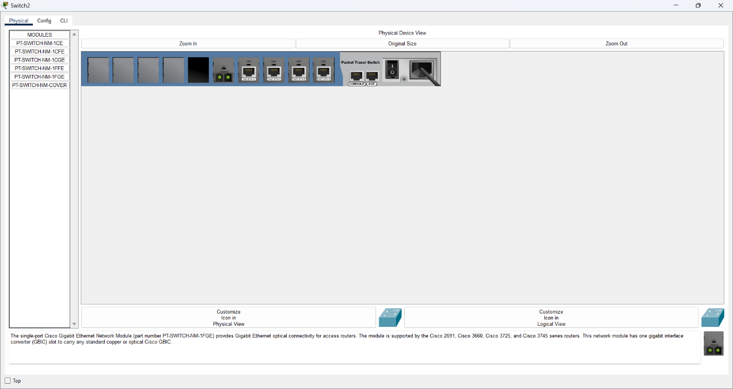

Which module can you insert to provide a Gigabit optical connection to **Switch3**?

**Answer:**

The module that can be inserted in order to connect to Gigabit Optical to Switch 3 is to use the PT-SWITCH-NM-1FGE type.

***ur answers here.***

**Step 2: Add the correct modules and power up devices.**

1. Click **East** and attempt to insert the appropriate module from Step 1a. Modules are added by clicking the module and dragging it to the empty slot on the device.

The **Cannot add a module when the power is on** message should display. Interfaces for this router model are not hot-swappable. The device must be turned off before adding or removing modules. Click the power switch located to the right of the Cisco logo to turn off **East**. Insert the appropriate module from Step 1a. When done, click the power switch to power up **East**.

**Answer:**

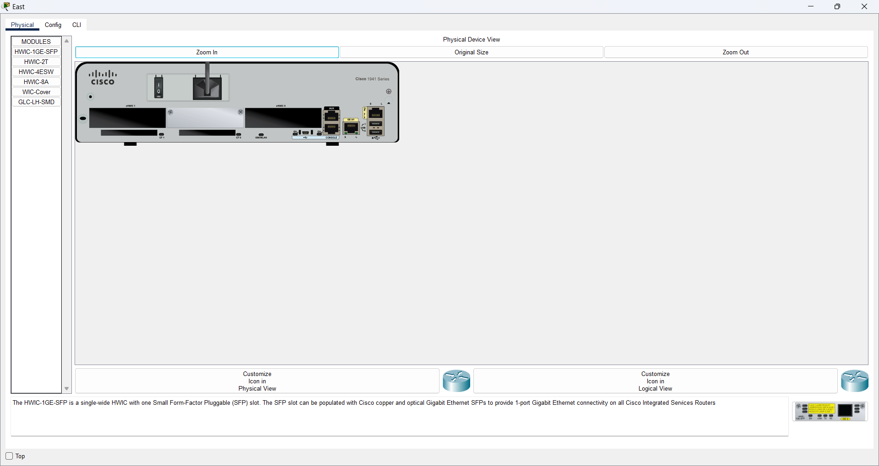

**Choose HWIC-2T and HWIC-4ESW**

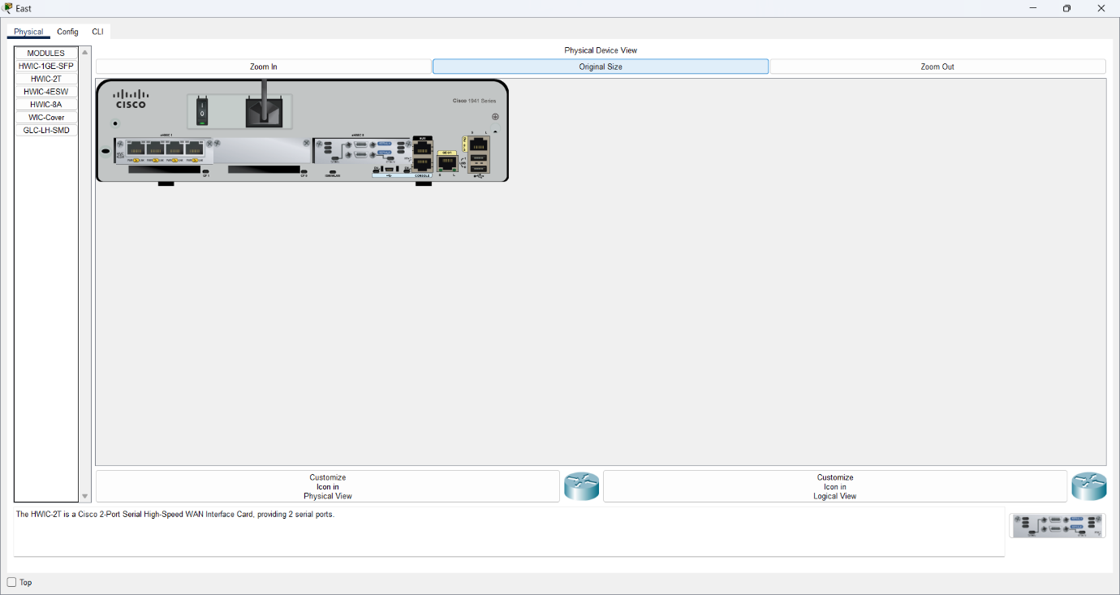

**Note**: If you insert the wrong module and need to remove it, drag the module down to its picture in the bottom right corner, and release the mouse button.

1. Using the same procedure, insert the module that you identified in Step 1b into the empty slot farthest to the right in **Switch2**.

**Answer:**

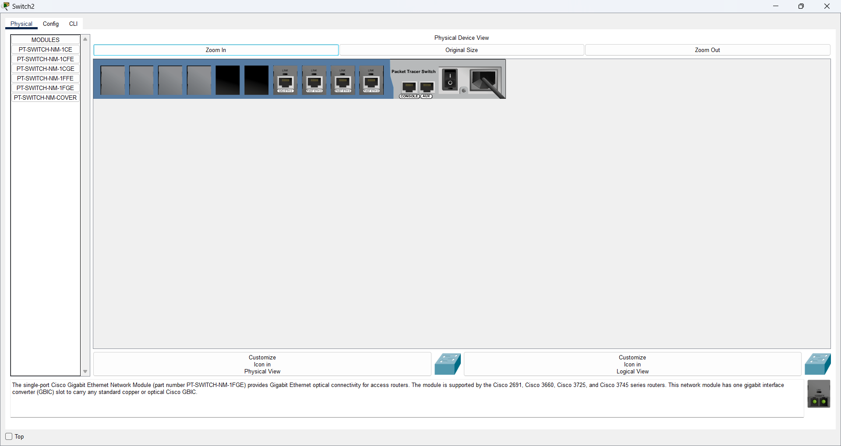

**Choose PT-SWITCH-NM-1CGE and PT-SWITCH-NM-1FFE**

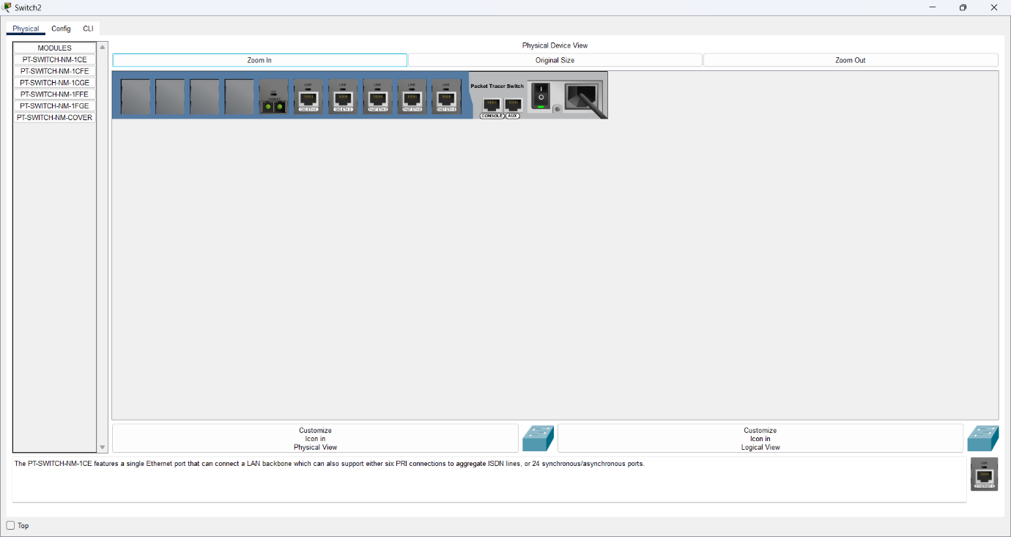

1. Use the **show ip interface brief** command on **Switch2** to identify the slot in which the module was placed.

**Answer:**

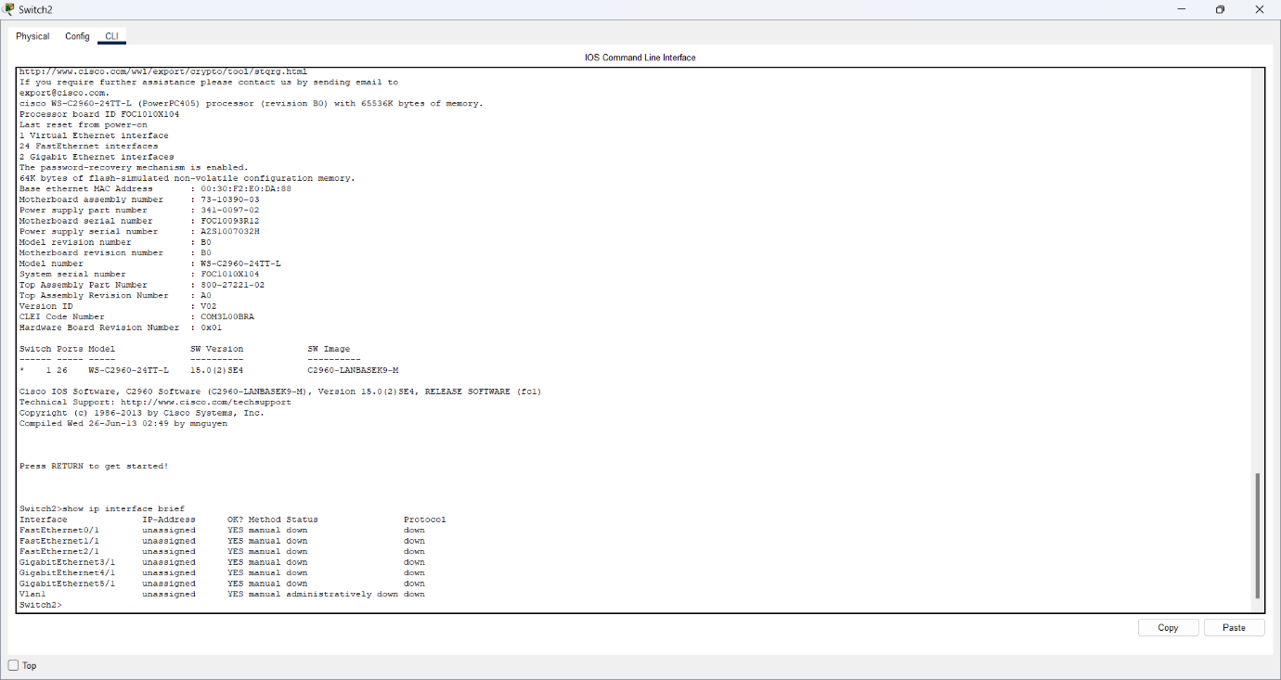

Into which slot was it inserted?

**Answer:**

The slot inserted is GigabitEthernet5/1

**Part 3: Connect Devices**

This may be the first activity you have done where you are required to connect devices. Although you may not know the purpose of the different cable types, use the table below and follow these guidelines to successfully connect all the devices:

1. Select the appropriate cable type.
2. Click the first device and select the specified interface.
3. Click the second device and select the specified interface.
4. If you have correctly connected two devices, you will see your score increase.

**Example**: To connect **East** to **Switch1**, select the **Copper Straight-Through** cable type. Click **East** and choose **GigabitEthernet0/0**. Then, click **Switch1** and choose **GigabitEthernet0/1**. Your score should now be 4/55.

**Note**: For the purposes of this activity, link lights are disabled.

|  |  |  |  |  |
| --- | --- | --- | --- | --- |
| **Device** | **Interface** | **Cable Type** | **Device** | **Interface** |
| East | GigabitEthernet0/0 | Copper Straight-Through | Switch1 | GigabitEthernet0/1 |
| East | GigabitEthernet0/1 | Copper Straight-Through | Switch4 | GigabitEthernet0/1 |
| East | FastEthernet0/1/0 | Copper Straight-Through | PC1 | FastEthernet0 |
| East | FastEthernet0/1/1 | Copper Straight-Through | PC2 | FastEthernet0 |
| East | FastEthernet0/1/2 | Copper Straight-Through | PC3 | FastEthernet0 |
| Switch1 | FastEthernet0/1 | Copper Straight-Through | PC4 | FastEthernet0 |
| Switch1 | FastEthernet0/2 | Copper Straight-Through | PC5 | FastEthernet0 |
| Switch1 | FastEthernet0/3 | Copper Straight-Through | PC6 | FastEthernet0 |
| Switch4 | GigabitEthernet0/2 | Copper Cross-Over | Switch3 | GigabitEthernet3/1 |
| Switch3 | GigabitEthernet5/1 | Fiber | Switch2 | GigabitEthernet5/1 |
| Switch2 | FastEthernet0/1 | Copper Straight-Through | PC7 | FastEthernet0 |
| Switch2 | FastEthernet1/1 | Copper Straight-Through | PC8 | FastEthernet0 |
| Switch2 | FastEthernet2/1 | Copper Straight-Through | PC9 | FastEthernet0 |
| Switch2 | Gigabit3/1 | Copper Straight-Through | AccessPoint | Port 0 |
| East | Serial0/0/0 | Serial DCE  (connect to East first) | West | Serial0/0/0 |

**Answer:**

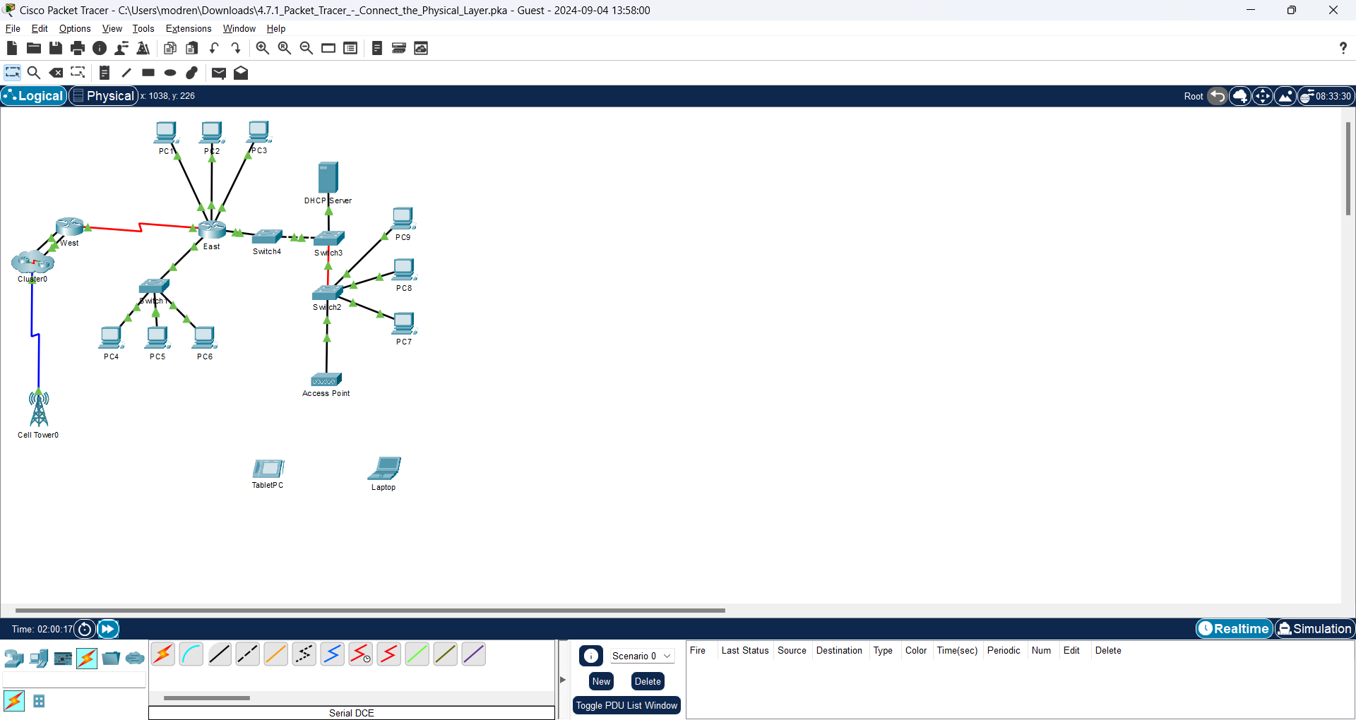

**Part 4: Check Connectivity**

**Step 1: Check the interface status on East.**

1. Click the **CLI** tab and enter the following commands:

East> **show ip interface brief**

Compare the output to the following:

Interface IP-Address OK? Method Status Protocol

GigabitEthernet0/0 172.30.1.1 YES manual up up

GigabitEthernet0/1 172.31.1.1 YES manual up up

Serial0/0/0 10.10.10.1 YES manual up up

Serial0/0/1 unassigned YES unset down down

FastEthernet0/1/0 unassigned YES unset up up

FastEthernet0/1/1 unassigned YES unset up up

FastEthernet0/1/2 unassigned YES unset up up

FastEthernet0/1/3 unassigned YES unset up down

Vlan1 172.29.1.1 YES manual up up

If all of the cabling is correct the outputs should match.

**Answer:**

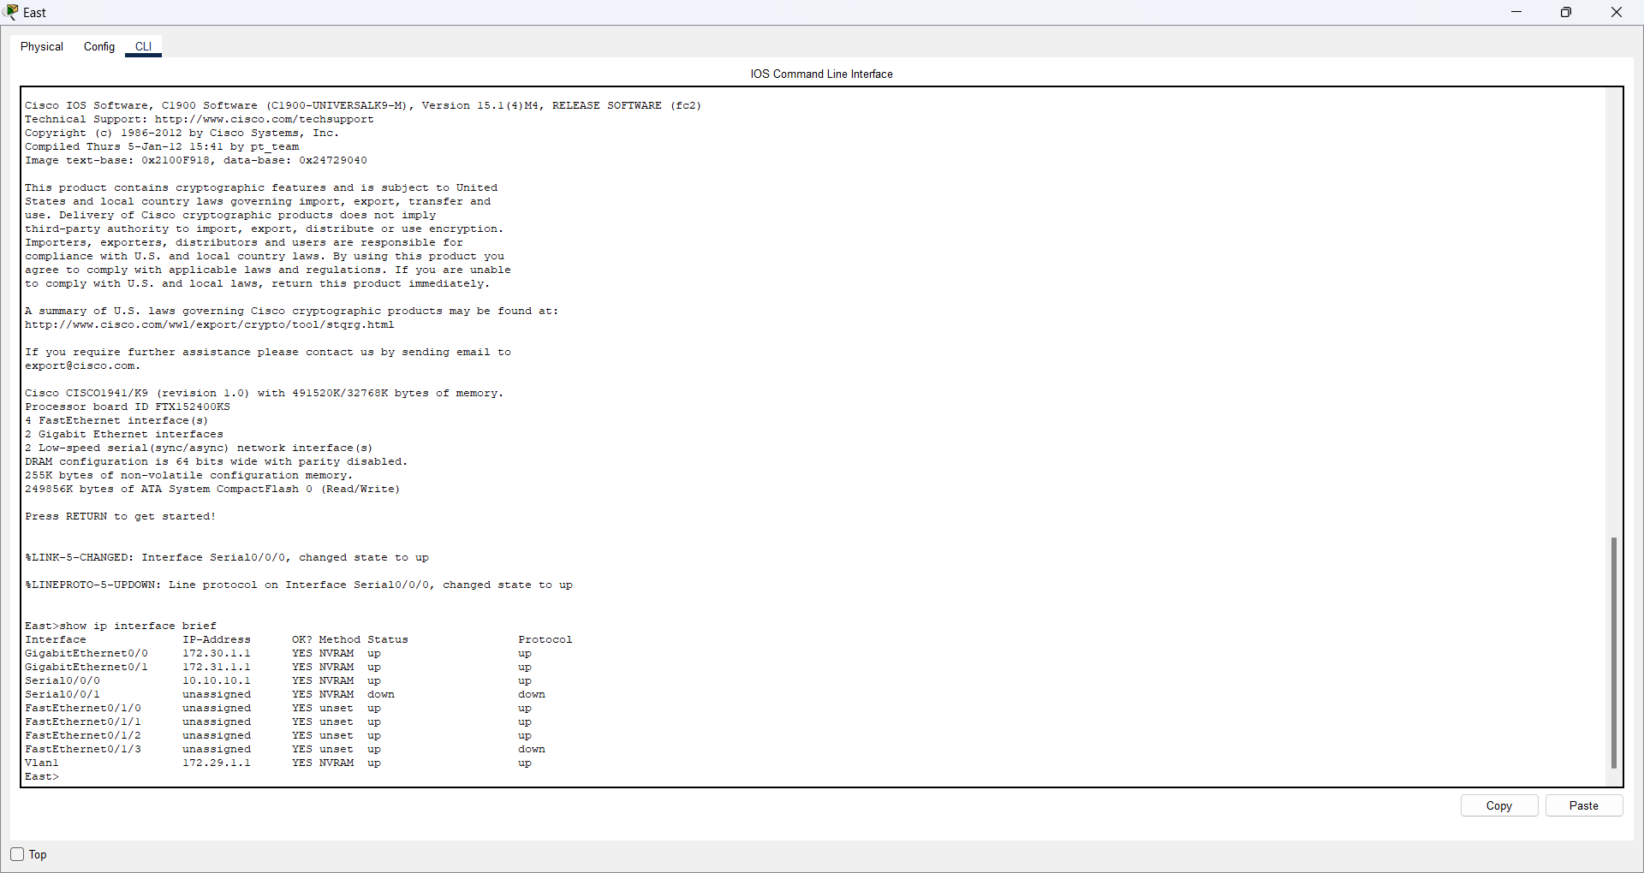

**Step 2: Connect wireless devices, Laptop and TabletPC.**

1. Click the Laptop and select the **Config** Tab. Select the **Wireless0** interface. Put a check in the box labeled **On** next to Port Status. Within a few seconds the wireless connection should appear.

**Answer:**

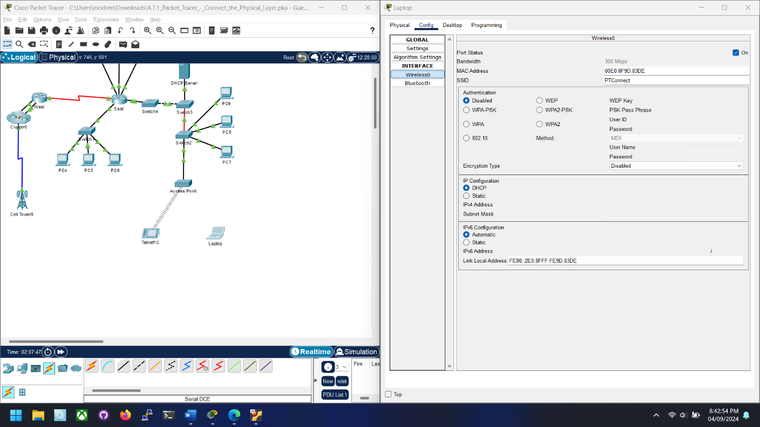

1. Click the **Desktop** tab of the **Laptop**. Click on the **Web Browser** icon to launch the web browser. Enter **www.cisco.pka** in the URL box and click **Go**. The page should display **Cisco Packet Tracer**.

**Answer:**

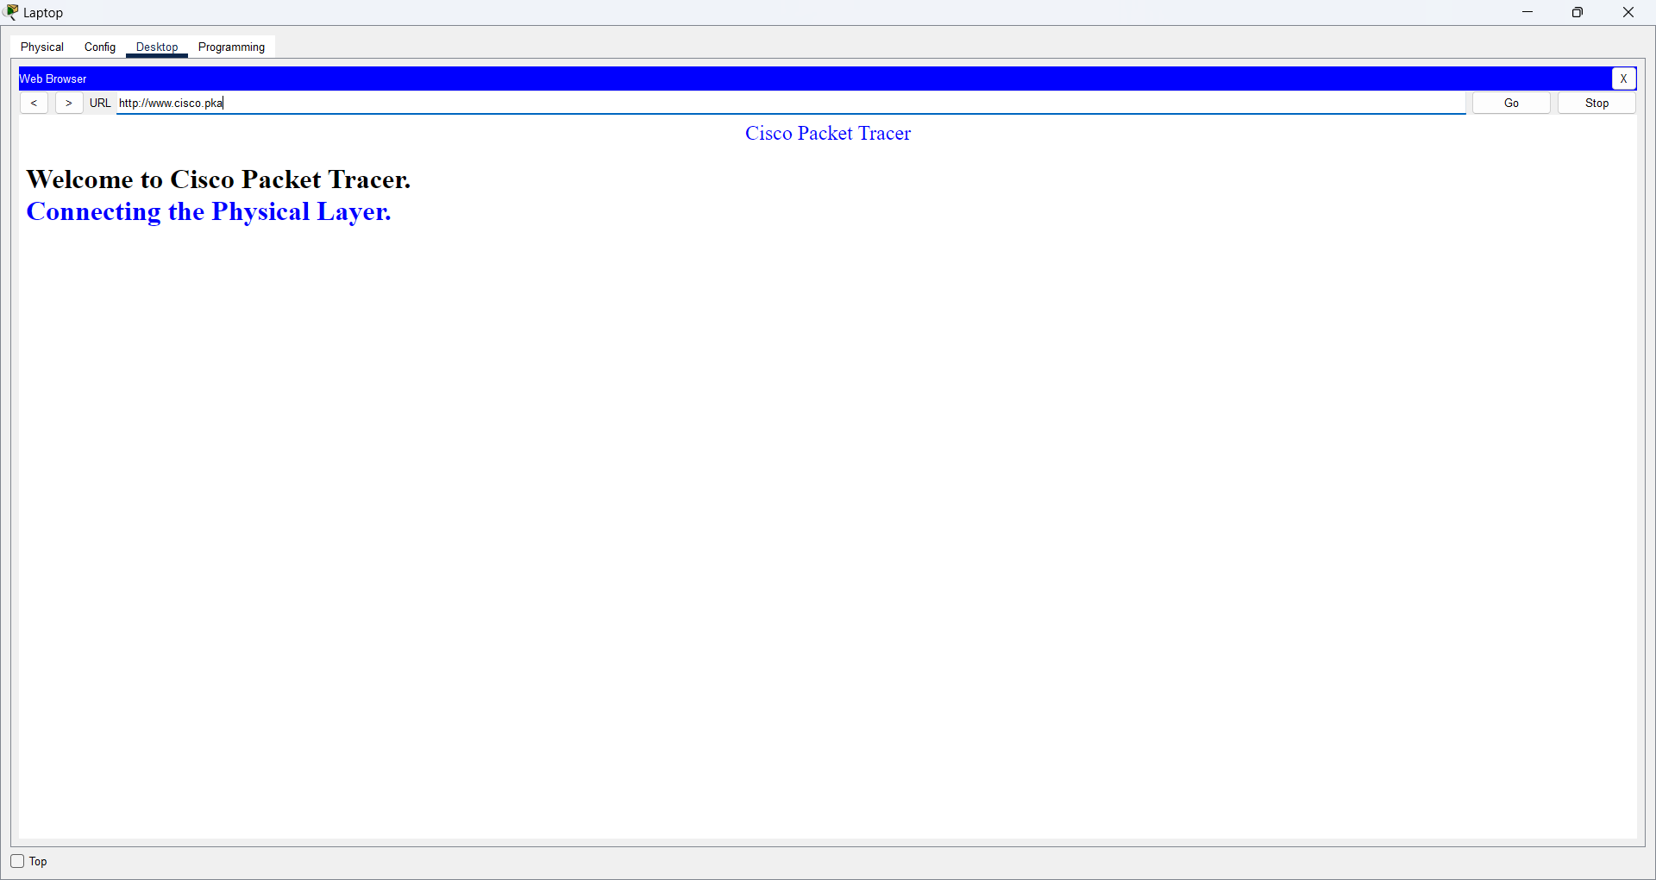

1. Click the TabletPC and select the **Config** Tab. Select the **Wireless0** interface. Put a check in the box labeled **On** next to Port Status. Within a few seconds the wireless connection should appear.

**Answer:**

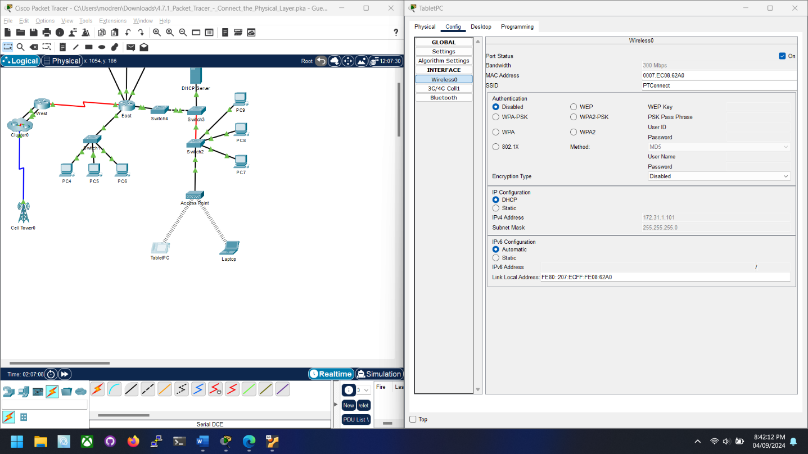

1. Repeat the steps in Step 2b to verify the page displays.

**Answer:**

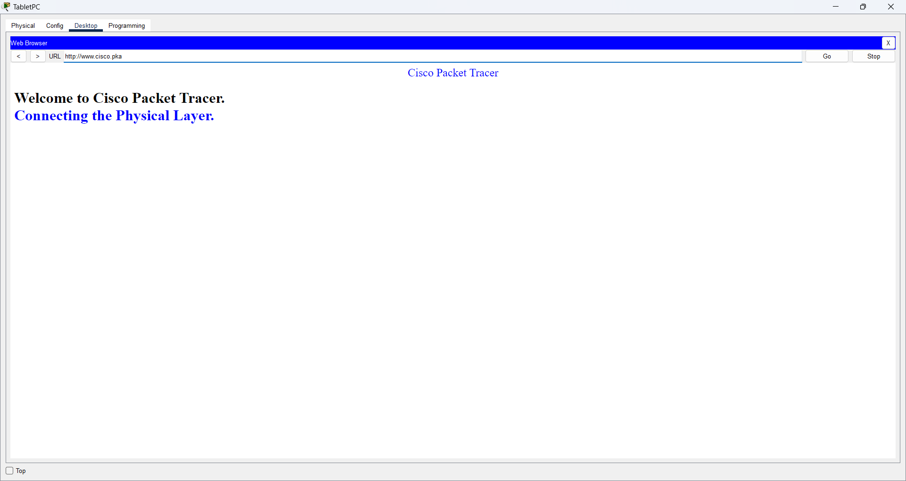

**Step 3: Change the access method of the TabletPC.**

1. Click the TabletPC and select the **Config** Tab. Select the **Wireless0** interface. Uncheck the box labeled **On** next to Port Status. It should now be clear and the wireless connection will drop.

**Answer:**

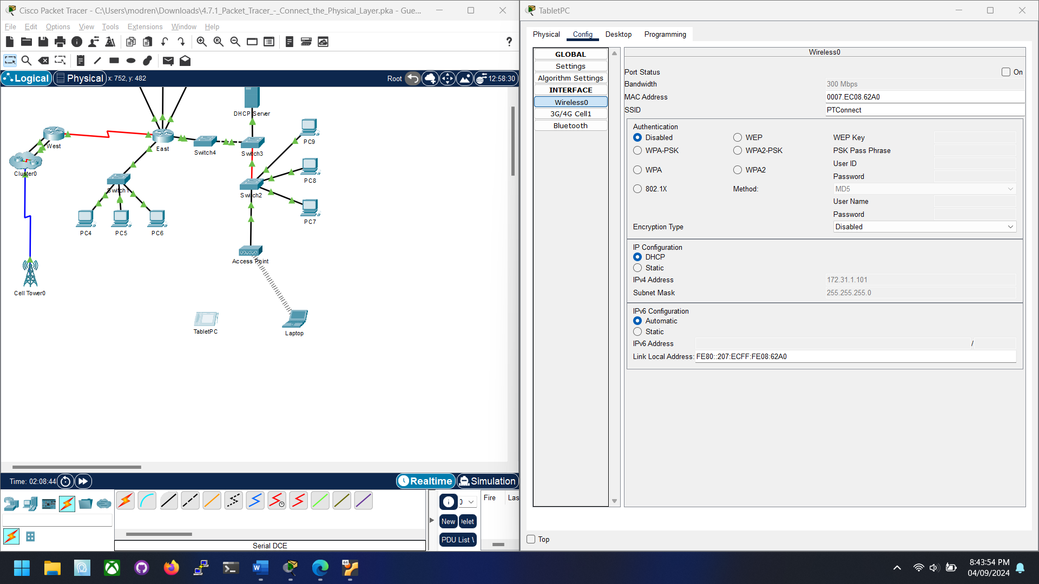

1. Click the **3G/4G Cell1** interface. Put a check in the box labeled **On** next to Port Status. Within a few seconds the cellular connection should appear.

**Answer:**

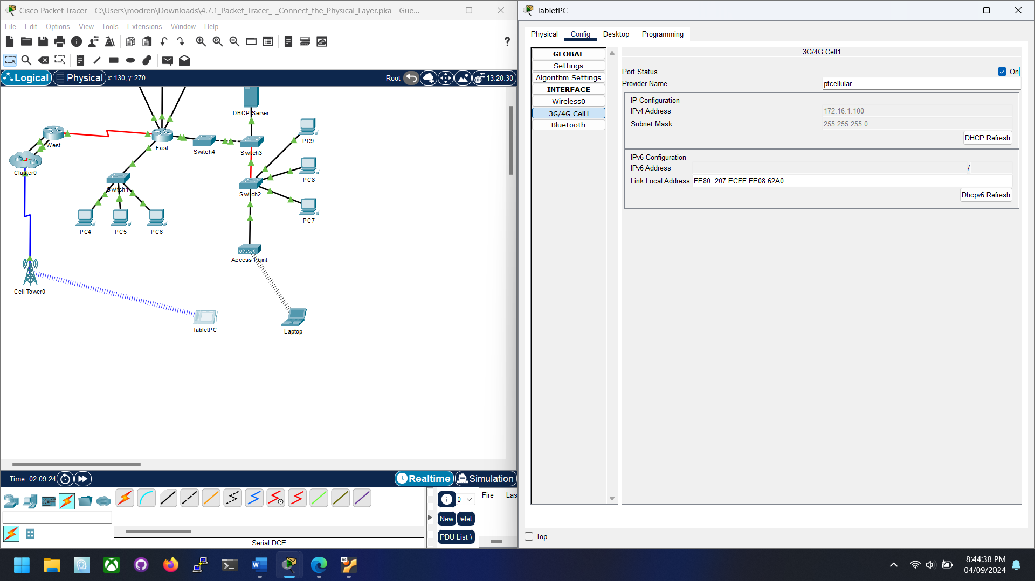

1. Repeat the process of verifying web access.

**Answer:**

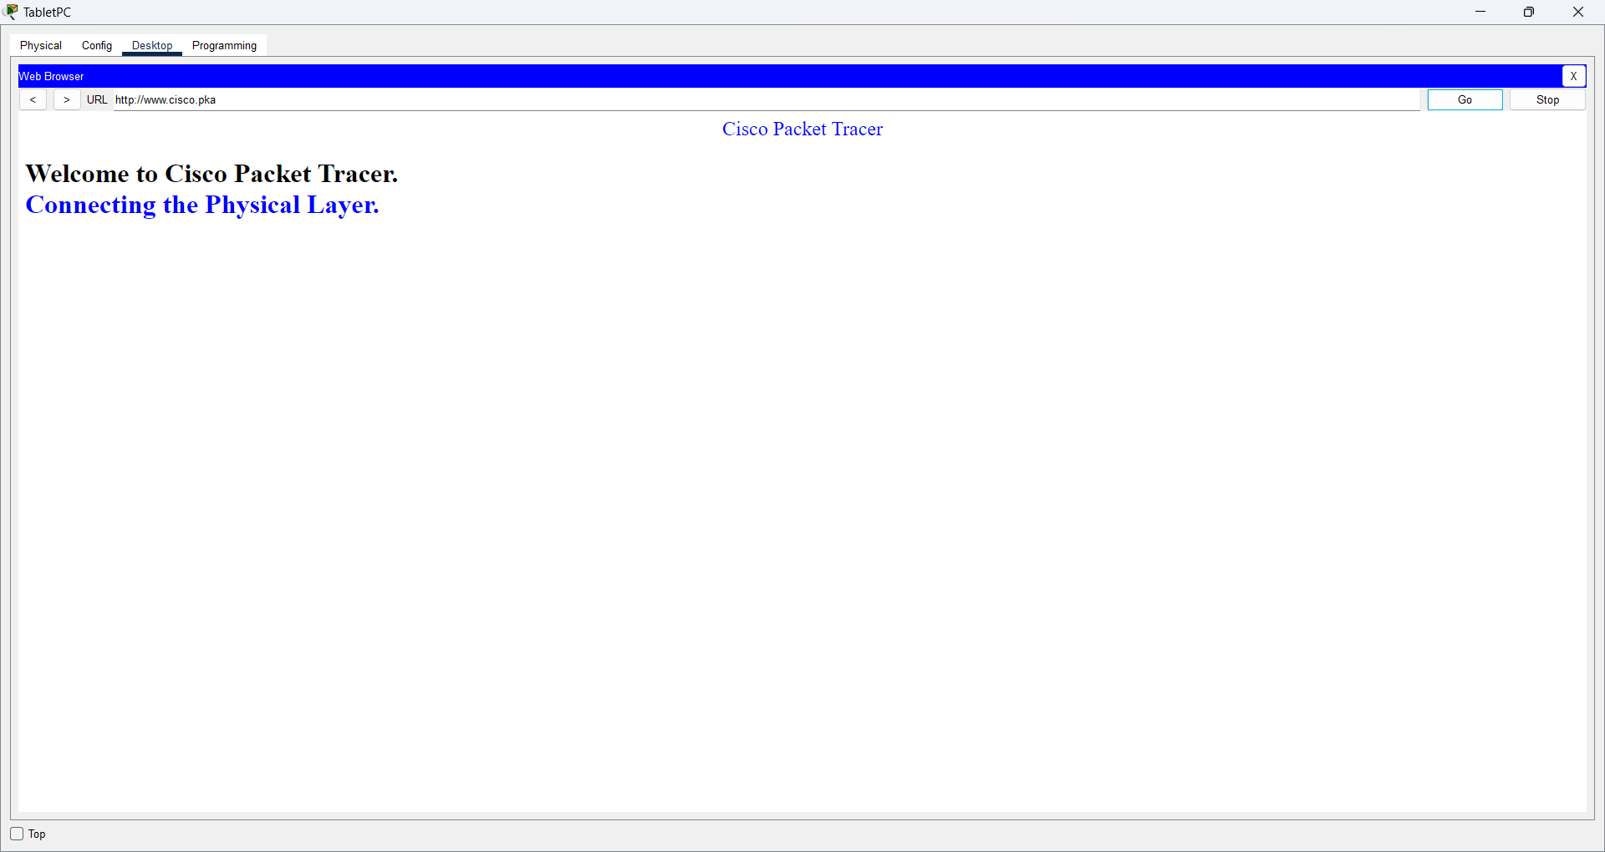

**Note**: You should not have both the wireless0 interface and 3G/4G Cell1 interfaces active at the same time. This may cause confusion to the device when attempting to connect to some resources.

**Step 4: Check connectivity of the other PCs.**

All of the PCs should have connectivity to the web site and each other. You will learn to use connectivity testing in many upcoming labs.